Southampton Solent University

SCHOOL OF MEDIA, ARTS AND TECHNOLOGY

**BSc (Hons) Computer Games (Software Development)**

**2019**

**Flavio Fiori**

**“Procedural Terrain Generation”**

***“The title of your dissertation”***

Supervisor : Philip Alassad

Date of submission : Working on Progress

Contents

1. Progress Report 4

1.1 Overview 4

1.1.1 Project 4

1.1.2 Why I want to undertake this project and how it is going to challenge me 4

2.1.3 Aims 6

2.1.4 Objectives 6

2.1.5 Stretch Goals 7

2.2 Project Specification 7

2.2.1 Software 7

2.3 Research 8

2.3.1 Perlin Noise 8

2.3.2 Diamond-Square Algorithm 12

2.3.3 Simplex Noise 16

2.3.4 Thermal erosion 16

2.4 Prototyping 17

2.5 Project Management 18

2.5.1 Methodologies 18

2.5.2 Tools for Time Management 21

2.6 Design 23

2.6.1 High Level Flow Chart 24

2.6.2 Perlin Noise Class 25

2.6.3 Mesh Generation Class 25

2.6.4 Map Generation Class 26

2.7 Project Plan 27

2.7.1 Time estimation 27

2.7.2 Feasibility and Risk 30

2.7.3 Risk Analysis 31

3. Final Report 32

3.4 Sprint 4 – Implementing the Mesh Generator class to display the heightmap 27/02/2019 – 08/03/2019 32

3.5 Sprint 5 – Graphic interface to change the terrain generation on the go and Level of detail implementation 09/03/2019 – 18/03/2019 36

3.6 Sprint 6 – Studying fractals and fractal implementation for future using in hydraulic erosion 22/03/2019 – 05/04/2019 42

3.7 Sprint 7 – Hydraulic erosion 06/04/2019 – 01/05/2019 53

References 54

Bibliography 56

Appendix 59

Appendix A) Reading List 59

Appendix B) Literature review 60

B.1) Terrain Synthesis Techniques Research 60

B.2) Perlin Noise Research 61

B.3) Diamond-Square Research 63

Appendix C) Images 64

C.1) Prototype using the 2D Perlin noise function that I created 64

C.2) Prototype using the Unity Perlin Noise Function 64

C.3) Perlin Noise from my function 65

C.4) Perlin Noise from unity 66

C.5) Ken Perlin’s original gradient function 66

C.6) Riven Calculate Perlin Noise twice as fast 67

C.7) Noise Displaced super quadric with old interpolants 67

C.8) Noise Displaced super quadric with new interpolants 68

C.9) Risk and Analysis 69

C.10) Gantt Chart 70

# Progress Report

## Overview

### Project

The goal is to create a procedural generation of terrain, where the user can define the size of it. Randomly generate a smooth transition from mountains to valleys, simulating a terrain and applying textures in relation of the type of terrain. The end goal is to be able to create a plug-in for Unity that allows random terrain generation inside the editor, without the need for the user to design and generate terrain.

### Why I want to undertake this project and how it is going to challenge me

I have chosen this project for two reasons: personal interest in terrain generation and to increase my employabilityskills, as technical programmers that can develop modular tools are highly requested in the games industry and are a great asset to any team. I aim to increase my C# skills as also to overcome any challenge that comes with programming randomly generated terrains such as the algorithms that are involved or Hight maps. The final product should be of industry standard and I would like to design it in a user friendly manner so that it could be launched in the Unity Asset store. In order to achieve the goal, I will also have to apply and improve my time management skills.

### 2.1.3 Aims

The aim of this project is to create a procedural terrain generation.

This project will contain different researches into what are the most cost-efficient terrain synthesis techniques to use for procedural terrain generation.

When the terrain generation is successfully complete, a method for synthesis of eroded terrain is going to be implemented (Olsen, 2004).

### 2.1.4 Objectives

* Research the best algorithms to create procedural terrain.
* Implement one of the three algorithms to create procedural generated terrain:
* Perlin Noise
* Diamond-Square
* Simplex Noise
* Create a 3D wireframe in unity using the algorithm selected
* Implement an algorithm for eroded terrain
  + Thermal erosion
* Implement the Diamond-Square algorithm to create the noise and generate the height maps using this algorithm.
* Implement the Simplex Noise algorithm to create the noise and generate the height maps using the algorithm.
* In unity editor the user can chose what algorithm use when generating the terrain.

### 2.1.5 Stretch Goals

* Create the procedural terrain generation plug-in for unity
* Implement the terrain synthesis techniques in C++ and OpenGL
* Create the Graphic class
* Create the Mesh Class
* Generate a 3D terrain using the terrain synthesis technique

## 2.2 Project Specification

### 2.2.1 Software

The required software needed is Visual Studio, Unity, Microsoft Excel, Microsoft Word, GitHub, Gantt Project, Visio, Photoshop, Kanbanflow, HacknPlan, and Google Drive.

* Visual studio is my favourite IDE for creating the scripts in C#.
* Unity is the 3D engine that will be responsible to handle and render the procedural terrain.
* Microsoft Excel is the program that will be responsible to create the work schedule for each week
* Microsoft Word allows me to create the documentation for the project.
* Github and Google Drive is where the backups of the project are stored.
* Gantt Project is the responsible program to create the Gantt chart for this project.
* Visio is where I am going to create the UML Class Diagrams for the project.
* Photoshop is used for the making of the terrain textures.

## Research

### 2.3.1 Perlin Noise

#### 2.3.1.1 What it is

Perlin Noise is a type of gradient noise created by Ken Perlin in 1983. Noise can be used to create a wide variety of natural looking textures. When combining noise into mathematical expressions it is possible to achieve procedural textures. The benefits of procedural textures is that they do not need a source texture image. They can be applied directly to 3D objects without the need to create the texture mapping responsible to wrap the texture around the object.

#### 2.3.1.2 How it works

1. In the noise method parameter, an initial value is given

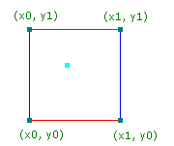

Figure 1 - Initial values the 4 grid points

1. The original algorithm created the pseudo-random gradient the following way: $R^{n} to R$. Currently the most common uses are for n=1 (animations), n=2 (cheap texture hacks), n=3 (less-cheap texture hacks) (Perlin 2001).
2. For each coordinate:
   1. Generates a pseudo-random gradient vector
   2. This gradient vector defines a positive direction and a negative one.

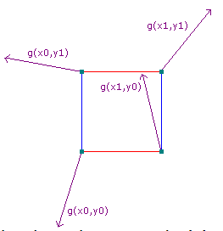

Figure 2 - Pseudorandom gradient

1. Linearly combine a weighted sum, using the function to ease the curve in each dimension ${3t}^{2}-{2t}^{3}$. This function is applied to the U and V values. This make changes more gradual as one approaches integral coordinates.

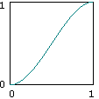

Figure 3 - Ease Curve

##### 2.3.1.2.1 The 4 neighbours in two dimensions

In two dimensions, there are 4 surrounding grid points. For each grid point, a vector going from the grid point to (x,y) is generated, this is easily obtained by subtracting the grid point from (x,y).

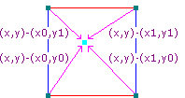

Figure 4 - The 4 neighbours

#### 2.3.1.3 Changes in the Perlin Noise Algorithm

During the research it was discovered that the original Perlin Noise created in 1983 had two deficiencies in the algorithm. One of them was the gradient computation, to fix this problem Ken Perlin discovered that was not necessary the G equation to be random at all. In the journal Improving Noise the G function was replaced by 12 vectors defined by the directions from the centre of a cube to its edges instead of the original G equation that take each grid point and assigns a pseudorandom vector of length 1 in R^2 (Perlin, 2002). The other deficiency was found in the function to ease the curve, see (Appendix C.7) (Appendix C.8)

“The above algorithm is very efficient but contains some deficiencies. One is in the cubic interpolant function's second derivative 6-12t, which is not zero at either t=0 or t=1. This nonzero value creates second order discontinuities across the coordinate-aligned faces of adjoining cubic cells.” (Perlin, 2002)

### 2.3.2 Diamond-Square Algorithm

#### 2.3.2.1 What it is?

Diamond-Square algorithm is a method to create a fractal landscape. A fractal landscape is a simulation of a natural terrain appearance. This algorithm was introduced by Alain Fournier, Don Fussel and Loren Carpenter at the annual conference on computer graphics named SIGGRAPH (Fournier, Fussell and Carpenter, 1982).

#### 2.3.2.2 How it works?

Diamond-Square algorithm works basically this way, first you need to create a 2D vertex field, where it is expressed in the following form: $2^{n}+1$. This makes sure that for every set of vertices on the corner, there will always be a vertex on the centre (Olse, 2004).

The algorithm is made by three steps:

1. Initialize Values
2. Perform the diamond step
3. Perform the Square step

##### 2.3.2.2.1 Initialize Values

The algorithm starts to initialize the array values for the initial four corner points within a specific range set by the user.

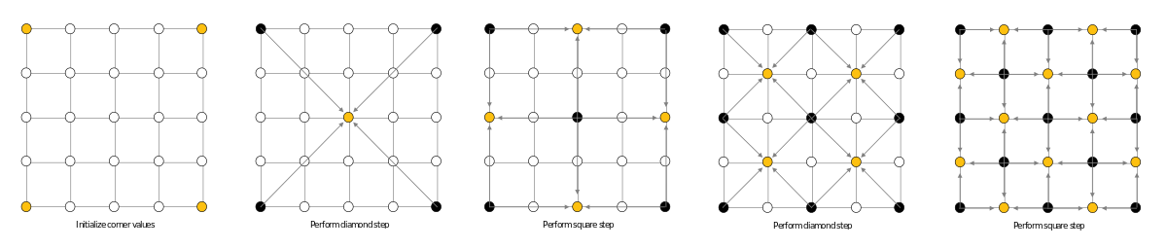

Figure 5 - Diamond-Square Initializing the corner values

##### 2.3.2.2.2 Diamond Step

The diamond step, consists of going through each square in the array, set a centre of that square to be the result of the average of the four corner points plus a random value.



Figure 6 - Diamond-Square performing the diamond step

##### 2.3.2.2.3 Square Step

In the square step for each diamond in the array, sets the midpoint of that diamond to be the average of the four corners plus a random value. For each iteration the random value is reduced, until there are no more vertices.

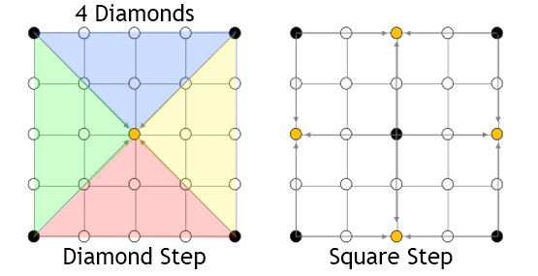

Figure 7 - Diamond-Square performing the square step



Figure 8 - Diamond-Square iteration

### 2.3.3 Simplex Noise

Simplex Noise is an algorithm created in 2001 by Ken Perlin to address the limitation of the Perlin Noise algorithm.

#### 2.3.3.1 Advantages compared to Perlin Noise

* Lower computational complexity, requiring a small number of multiplications, making it cheaper to compute than the Perlin Noise.
* Is visually isotropic, this means that the magnitude has the same value when measured in different directions.
* There are no more grid artefacts.
* Easier to implement in hardware.

### 2.3.4 Thermal erosion

Thermal Erosion is a process that simulates the breaking down of material, this breaking down then is moved by the wind or water to the bottom (Olse, 2004; Rohde, 2013).

#### 2.3.4.1 How it works

An amount of the material that is at the top of a slope whose inclination is above a threshold value, will be moved down in the slope.

## 2.4 Prototyping

When developing a prototype of the procedural terrain, the premade Unity Perlin Noise function was used to generate a noise map and after converting it to a colour map (Appendix C.2), this allowed to get an idea of the result of the prototype.

With the prototype in hand, I proceeded to implement the Perlin Noise function. This function was based on the java reference implementation of improved noise function with slight modifications.

When creating the noise function, few problems raised, one of them is the original Ken Perlin’s gradient function using complicated, and confusing bit-flipping code to calculate the dot product of a randomly selected vector and the 8 location vectors (Appendix C.5) (Perlin 2002).

An easy alternate way of writing the code and even fast to compile in many languages, is to write a switch statement with all the 16 possible cases from the 8 location vectors (Appendix C.6) (Riven 2010).

Is possible to see the first result of the 2D Perlin noise function that was implemented in the (Appendix C.1). While this function was far from perfect due to the fact that sometimes the output was negative, the result was satisfactory. To improve the function it was necessary to add the third axis (Z), to create a the correct output value (Appendix C.3) similar to the original Unity function (Appendix C.4).

## 2.5 Project Management

### 2.5.1 Methodologies

#### 2.5.1.1 Waterfall

In the waterfall methodology the scope of the project is defined in the beginning and cannot be changed once development starts.

The advantages of using waterfall methodology is the fact that it is going to help organize the project with defined tasks. In the future, if all the steps are followed, a complete product is achieved. The waterfall model is simple and easy to understand, each phase of the model has specific deliverable dates and review processes, helping to create a linear structure for the project (ISTQB 2013).

##### 2.5.1.1.1 Pros

* Simple to Implement
* Easier to manage due to the fact that the stages are more rigid
* Is great for small projects

2.5.1.1.2 Cons

* Difficult to make changes once the project begins
* Software is created near the end of the development cycle
* The risks are high and unpredictable
* Does not work well for long projects

#### 2.5.1.2 Agile

Agile use sprints, each sprint is a time period that is allocated for each phase of the project. A sprint is complete when the time defined for it expires. If the development of the project is not satisfactory in that sprint, or the tasks were not met, then that sprint is considered a fail, sending all the failed tasks to the next sprint and so on.

##### 2.5.1.2.1 Pros

* Software is created in the beginning of the development cycle
* Decreases the risk associated with software development
* Requirements can change during the development of the project, implementing new features, this helps companies create the right product for the market

##### 2.5.1.2.2 Cons

* It is more focused on the developer instead of the client
* Easy to get lost if no clear focus is applied in the final outcome
* Less focus on the product design
* Ineffective in large organizations

#### 2.5.1.3 Time-Box

Time-box is a short period of time that person works towards a specific goal. If this goal is not reached when the time period ends, then the person stops working on the project and start evaluating what went well, what went wrong, has the goal been met, or to some extent met (Rothman 2017).

##### 2.5.1.3.1 Pros

* Easy to implement
* Easy to follow
* Always updated with the project progress
* Focus on the important things under time constraints

##### 2.5.1.3.2 Cons

* Time consuming
* Sometimes work cannot be completed on time, causing unfinished products.
* Time estimation is not accurate

### 2.5.2 Tools for Time Management

#### 2.5.2.1 Trello

Trello is a project management application that uses the Kanban system. The projects are represented by boards, each of the boards contains a list of tasks. The tasks are represented by cards, that are created inside the boards.

“Trello is an online tool for managing projects and personal tasks. That may sound rather prosaic. But this increasingly popular app often inspires the sort of passion usually reserved for consumer apps like Pinterest or Instagram. It’s the kind of business software that slips into businesses through the backdoor, just because individual employees like how it works.” (Finley 2014)

#### 2.5.2.2 KanBanFlow

KanBan Flow is a cloud-based project management solution similar to trello, it uses the Kanban system but there is one thing that it excels compared to trello. KanbanFlow features the pomodoro technique for time tracking of tasks. This feature makes KanbanFlow my number one choice in time management tools (Software Advice 2017).

#### 2.5.2.3 HacknPlan

Basically, HacknPlan is an alternative of trello for game developers. The difference is that HacknPlan brings game design and task management together to provide a better organization while creating a game project. HacknPlan features stock headings with categories like programming, art, design, writing and more. Not only that but also each heading features different subcategories; In programming there is AI, Physics and more (Estevez 2019; GameDesigning 2018).

#### 2.5.2.4 Microsoft OneNote

Microsoft OneNote is an app that simulates a notebook, were the user can gather handwritten or typed notes, drawings or even audio commentaries.

## 2.6 Design

### 2.6.1 High Level Flow Chart

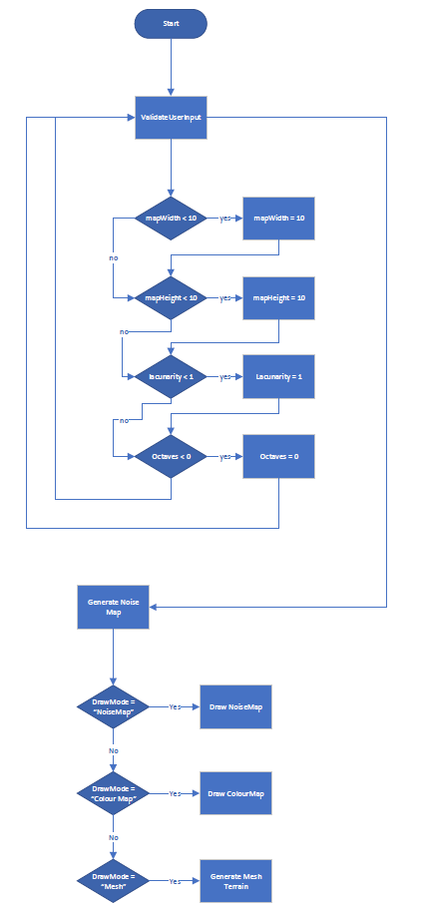

### 2.6.2 Perlin Noise Class

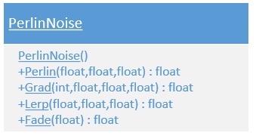

### 2.6.3 Mesh Generation Class

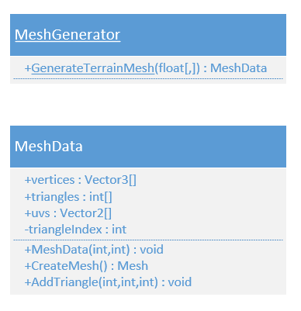

### 2.6.4 Map Generation Class

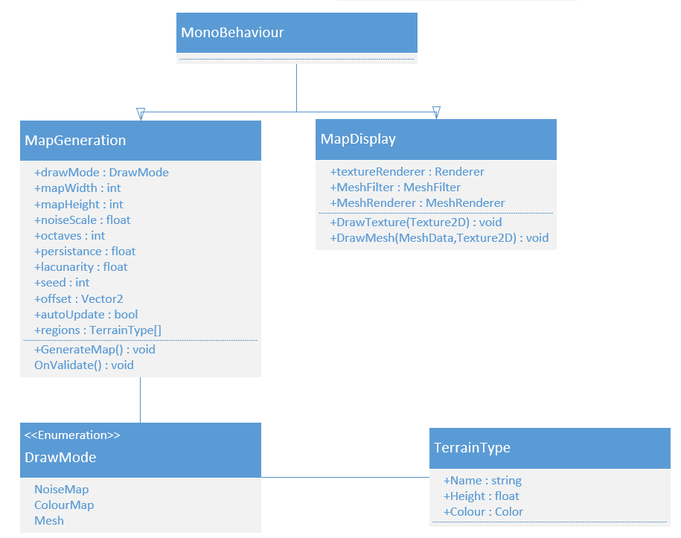

## 2.7 Project Plan

Planning a project beforehand is a critical process to ensure that the project is going to be completed successfully. To ensure that everything goes as planned, a methodology named “Time-Box” is going to be applied to the project.

At the start of each week, a Gant Chart and a work break down structure is going to be created, this will be called a sprint. The risks will be managed at the end of each sprint.

### 2.7.1 Time estimation

To see the full Gantt Chart, see Appendix C.10_Gantt_Chart)

#### 2.7.1.1 Sprint 1 – Initial Setup

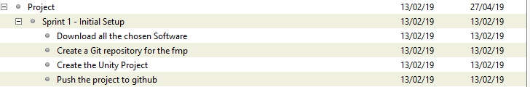

Figure 9 - Gantt Chart Sprint 1

#### 2.7.1.2 Sprint 2 – Algorithm Researching

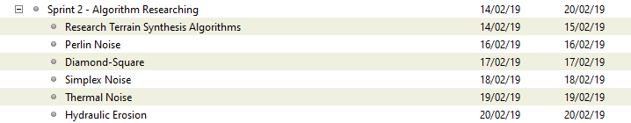

Figure 10 - Gantt Chart Sprint 2

#### 2.7.1.3 Sprint 3 – Finishing the Perlin Noise Function and Research in Terrain Synthesis techniques

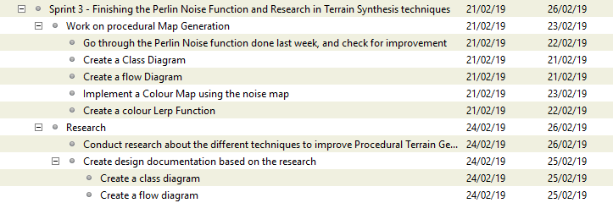

Figure 11 – Gantt Chart Sprint 3

Week 13/02/2019 – 23/02/2019

WBS

1. Work on the Procedural Map Generation (50%) (15 hours)
   1. Create a Class Diagram (5% Design)1h30m
   2. Create a flow Diagram (5% Design)1h30m
   3. Go through the Perlin Noise function done last week, and check for improvement (10% Programming)3h
   4. Implement a Colour Map using the noise map (20% Research/Programming)6h
   5. Create a colour Lerp Function (10% Research/Programming)3h
2. Research (50%) (15 hours)
   1. Conduct research about the different techniques to improve Procedural Terrain Generation (20% Research)
   2. Conduct research on the Diamond-square algorithm (20% Research)
   3. Create design documentation based on the research (10% Design)
      1. Create a class diagram (5% Design)
      2. Create a flow diagram (5% Design)

#### 2.7.1.4 Sprint 4 – Implementing the Mesh Generator class to display the heightmap



Figure 12 - Gantt Chart Sprint 4

#### 2.7.1.5 Sprint 5 – Graphic interface to change the terrain generation on the go



Figure 13 - Gantt Chart Sprint 5

#### 2.7.1.6 Sprint 6 – Implement Thermal Noise algorithm for terrain erosion



Figure 14 - Gantt Chart Sprint 6

#### 2.7.1.7 Sprint 7 – Implement Hydraulic Erosion algorithm



Figure 15 - Gantt Chart Sprint 7

#### 2.7.1.8 Sprint 8 – Create a Unity Plug-in and Work on the final report



Figure 16 - Gantt Chart Sprint 8

### 2.7.2 Feasibility and Risk

To prevent any risk from occurring, I am going to use time management techniques like pomodoro and Kanban (Cirillo 2006; Cummings 2018; Cirillo 2017; Marcus Hammarberg and Joakim Sundén 2014; Anderson 2010; Peterson 2015).

I believe that creating a terrain generator with Hight maps is a feasible project, for avoiding some of the risks, I will make sure that I work at least 30 hours per week on the project. To see the risks that may occur during the development of this project see the Risk Analysis (Appendix C.9).

### 2.7.3 Risk Analysis

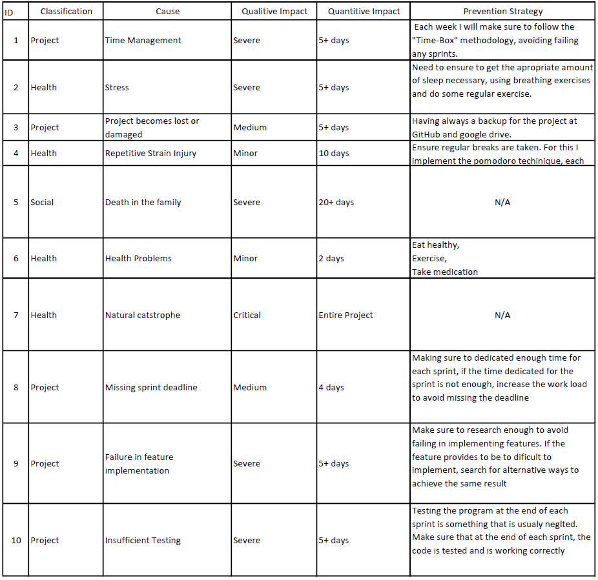

# Final Report

## 3.1 Sprint 1 – Initial Setup 13/02/2019 – 13/02/2019

### Abstract

The purpose of this sprint is to download the required software for the development of the Procedural Terrain Generation. The project is going to be backed up in GitHub. Git is a version control and source code management. At the end of this sprint the project should be ready for development.

### Research / Implementation

During this sprint the author searched for everything that needed for creating this project.

The necessary programs that are going to be used for the development of the procedural terrain generation are the following:

#### Unity Engine

Update for the latest possible version of Unity before starting the project (Ver. 2018.3.3f1). The Unity engine is responsible for rendering the 3D graphics of the terrain.

#### Visual Studio

Preferred IDE by the author for programming.

#### Gantt Project

The program responsible to create the Gantt chart

At the end when everything was downloaded, the author created a Unity project, script folder and a sprint folder, where each sprint is going to have an individual word document. When all of this was created the author pushed all the documents to Git.

### Sprint Review

The sprint was a success, nothing was challenging on this sprint, it involved only on the creation of a project and pushing the content to a git repository.

### WBS

1. Download all the chosen Software (70%) (3.5 hours)
2. Create a Git repository for the final major project (8%) (0.4 hours)
3. Create the Unity Project (6%) (0.3 hours)
4. Create the necessary project folders (8%) (0.4 hours)
5. Push the project to git (8%) (0.4 hours)

## 3.2 Sprint 2 – Algorithm Researching 14/02/2019 – 20/02/2019

### Abstract

The main goal of this sprint is researching the best algorithms for procedural terrain generation. Not only this sprint is going to be one of the most important ones but also it will dictate the outcome of the project.

### Research / Implementation

After researching for a while, the author created a list with the following terrain synthesis algorithms:

#### Perlin Noise

Perlin noise is an algorithm developed by Ken Perlin in 1983. This algorithm is used to create a type of noise that creates natural looking textures [2.3.1 Perlin Noise].

#### Diamond-Square

Diamond-Square is a well know algorithm for procedural terrain generation. It is created by Alain Fournier, Don Fussel and Loren Carpenter. Practically is called inside a recursive function until there are no more vertices to recurse from.

For more information in how this algorithm works check the section in the progress report [2.3.2 Diamond-Square Algorithm].

#### Simplex Noise

Simple Noise is a new version from Perlin Noise made by Ken Perlin in 2001, this version was created to overcome some limitation of the Perlin Noise [2.3.3].

#### Thermal Noise

Thermal Noise is an algorithm responsible for terrain erosion through the breaking down of rocks, soil and minerals and they are moved by the wind to the bottom [2.3.4 Thermal Erosion].

#### Hydraulic Erosion

Hydraulic Erosion is a process that creates erosion through the water flow, practically there is composed by two things, one of them is the sediment capacity that the water can carry and another one is the deposit process. The water starts eroding the surfaces it touches and carries that surface as sediment, when the sediment capacity of the water reaches to its maximum amount it starts to deposit that sediment.

### Sprint Review

This sprint was a success, at the end it is possible to conclude that the author learned the most used algorithms for terrain generation and the two most common used algorithms for terrain erosion. The author then decided to choose the Perlin Noise algorithm for the noise map generation and hydraulic erosion for implementing the terrain erosion.

### WBS

1. Research Terrain Synthesis Algorithms (30%) (9 hours)
2. Perlin Noise (14%) (4.2 hours)
3. Diamond-Square (14%) (4.2 hours)
4. Simplex Noise (14%) (4.2 hours)
5. Thermal Noise (14%) (4.2 hours)
6. Hydraulic Erosion (14%) (4.2 hours)

## 3.3 Sprint 3 – Finishing the Perlin Noise method and research in terrain synthesis techniques 21/02/19 – 26/02/19

### Abstract

The goal of this sprint is to finish the Perlin Noise class implementation, research ways to improve the terrain synthesis techniques, implementing some program design like the UML class diagram that describes the structure of the class.

### Research / Implementation

During the research for improving the Perlin Noise algorithm a journal named Improving Noise by Ken Perlin (Perlin, 2002) explained two deficiencies present on the algorithm; one of those was the fade method, this method is responsible for easing the curve and the other one was the gradient calculation.

#### Fade function

The first thing was improving the fade function by changing the formula, so the author replaced the method present in [Figure 1] to the new method present in [Figure 2].



Figure 1 - Original Fade Function

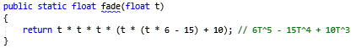

Figure 2 - Fade function improved

Just by simple changing the fade function it is possible to perceive the increased level of detail on the right image, the sand is creating a better pattern and it is possible to perceive that now the water is present in places that before was just sand. This is due to the fact that now the values get even closer to integral coordinates, in other words closer to 1 and 0 [Figure 3].

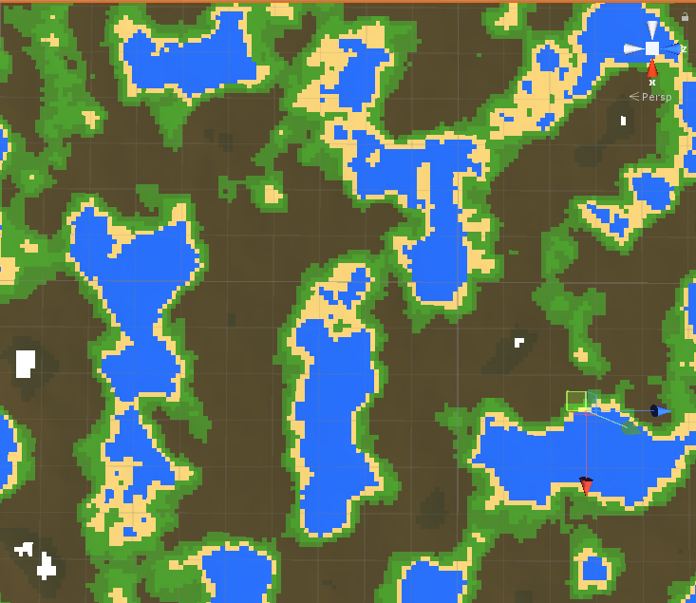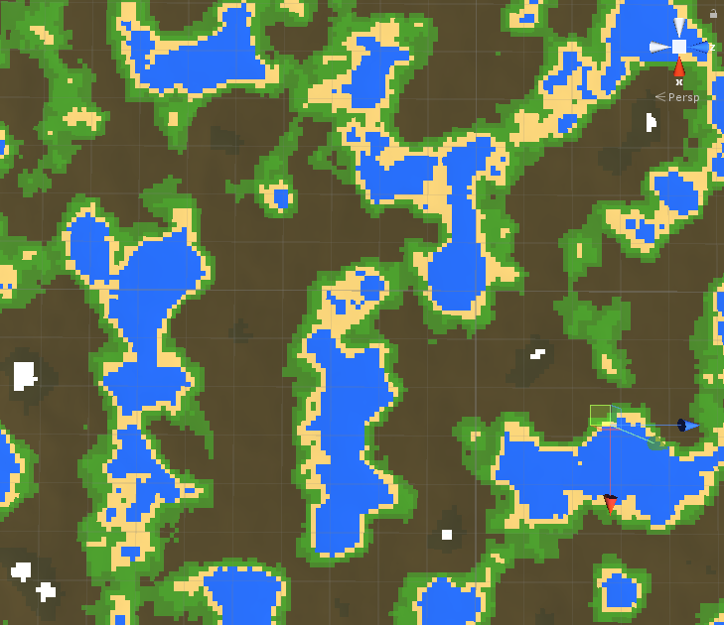

Figure 3 - Original Fade Function left, Improved fade function on the right.

#### Gradient Function

This function is used to calculate the dot product of a randomly selected gradient vector in 8 different locations. The original function [Figure 4] made by Ken Perlin’s uses complicated and confusing bit-flipping code to calculate the dot product and due to that fact, the author was not satisfied, he then decided to begin a research for an easy and more understandable solution.

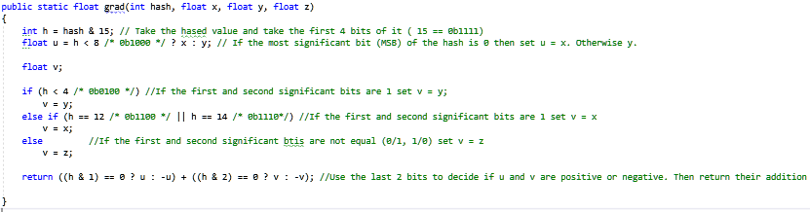

Figure 4 - Gradient Original Function

After a few hours of researching the author found a great solution that seems to have the same effect from the original one (Riven 2010); not only is easier to understand but is twice as fast from the original due to the fact that uses a switch statement and gets all the 16 possible outcomes from the gradient in a simple way instead of using bit manipulation [Figure 5].

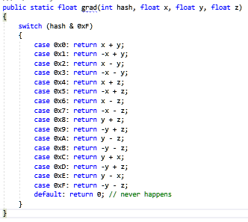

Figure 5 - Simple Gradient Function

To prove that the function gets the same result, in the [Figure 6] is possible to see the two different functions side by side, and that the result is totally identical.

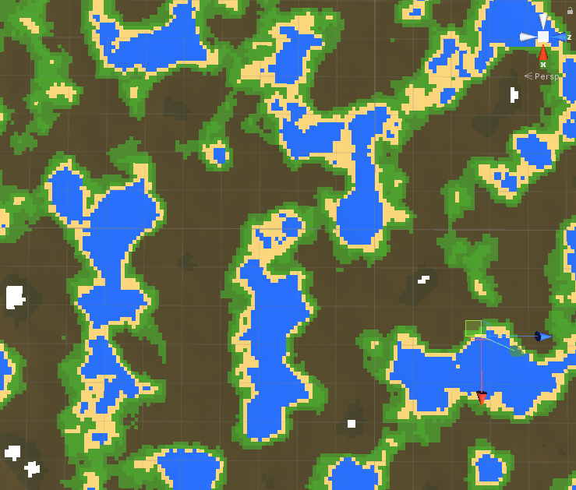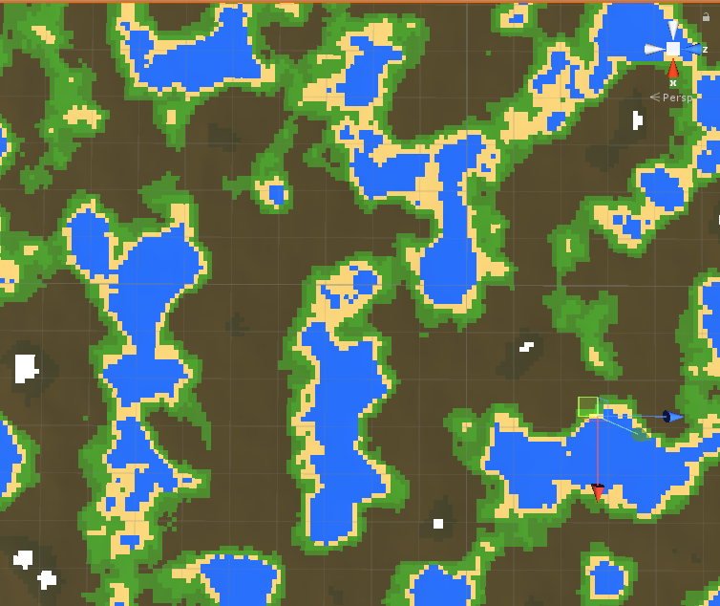

Figure 6 - Original Gradient function | Simple Gradient Function

#### Colour Map

##### Overview

For creating the colour map the author needed to find a way to pass some values using the user interface in unity. So, the first thing was to create a public struct with the three essential attributes; the name, noise height and the colour [Figure 7].

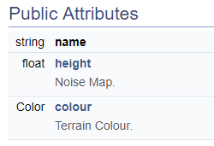

Figure 7 - Struct Attributes

Each of the terrains now can be defined in the unity interface, where the water colour is given for every part of the noise map that has the value between 0.00f - 0.35f while the sand colour is given to the values of between 0.36f - 0.40f. Due to this fact the grass is the last one, the green colour is given the noise values between 0.40 and 0.45f. [Figure 8] [Figure 9].

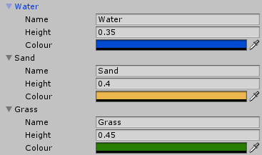

Figure 8 - Unity Array Type of Terrains

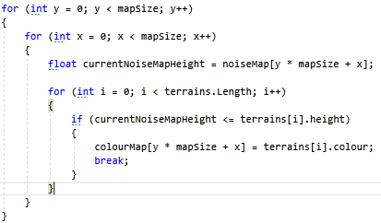

Figure 9 - Adding the colours to the colour map

##### Definition

In [Figure 10] it is possible to see how the ColourMap function is defined.

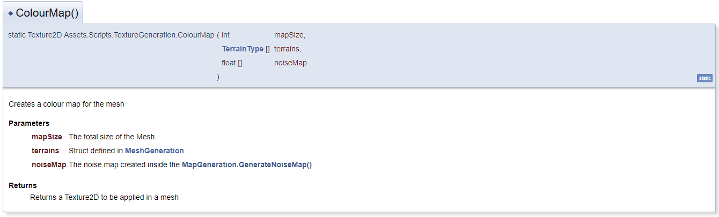

Figure 10 - TextureGeneration.ColourMap()

###### Map Size

The reason why the author passes the mapSize is for creating the total size of the array [Figure 11], and to be able to loop through all the vertices in the map, in this case 65 025 vertices.



Figure 11 – Colour Map array

###### Terrain Type

The TerrainType is essential for knowing how many terrains are defined by the user, going through the array by using the Length variable [Figure 12]. The other use is by getting the height defined by each of the terrains and check if the noise map is smaller or equals to the height, if this is true then apply the selected colour to the colourmap [Figure 13].



Figure 12 - Terrain Length

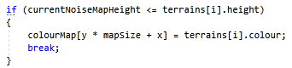

Figure 13 - Noise Map Height

###### Noise Map

The reason why the noiseMap[] is passed in the parameter list is due to the fact that the author needs to know what are the height values for each vertices position. It is possible to retrieve the noise value in that exact vertices location creating two for loops less than mapSize and then current noise map value for each iteration [Figure 14].



Figure 14 - Noise Map current value

###### Return

It returns a Texture2D with the size of mapSize in X and mapSize in the Y where the parameter in the function SetPixels() is the colourmap that was created in the code above.

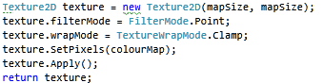

Figure 15 - Return Colour Map

### Sprint Review

The sprint was an overall success, not only the author learned how to improve the noise function and the two deficiencies that were present in the first algorithm made by Ken Perlin, but also learned how to use the noise values and convert them into a Textured2D for later use in any object or mesh.

### WBS

1. Work on procedural Map Generation (50%) (21 hours)
   1. Improve the Perlin Noise method (40%) (8 hours)
   2. Implement a Colour Map using the noise map (60%) (13 hours)
2. Research (50%) (21 hours)
   1. Research about Perlin Noise improvements (90%) (19 hours)
   2. Create a Class Diagram (5%) (1 hours)
   3. Create a Flow Diagram (5%) (1 hours)

## 3.4 Sprint 4 – Implementing the Mesh Generator class to display the heightmap 27/02/2019 – 08/03/2019

#### Abstract

The goal of this sprint is to create a class to generate a basic mesh during run time. The mesh is going to get the height map values and the colour from the colour map.

#### Research

I already had previously knowledge in how to create meshes in DirectX, and this uses the same principle.

#### Sprint Review

During the implementation of the class I struggled with different problems. The first problem was found on the initialization of the vertices, for example I created a vector3 named vertices with the size of $MapWidth * MapHeight$, let’s imagine that MapWidth and MapHeight have a value of 10, this means that the vector has a size of 100 in total. The only problem is that I wanted to have to have 10 quads per row, but for this I need to have 11 vertices per row. The problem was that the last vertices for the rightest corner quad were present in the other side of the map creating these strange connections (Figure 2).

The solution for this was to create the vertices with the size of $(MapWidth + 1)(MapHeight +1)$ (Figure 1)

The terrain generation was looking to soft and far from realistic (Figure 3), to resolve this problem I found that limiting the persistence level between 0 and 1 and increasing the lacunarity to 2.6 fixed the problem (Figure 4).

An animation curve from unity was implemented in the code to limit the height map range (Figure 5). In other words, an animation curve in unity has multiple keys in were the user can control the points in what that curve passes through (Unity Technologies 2018).

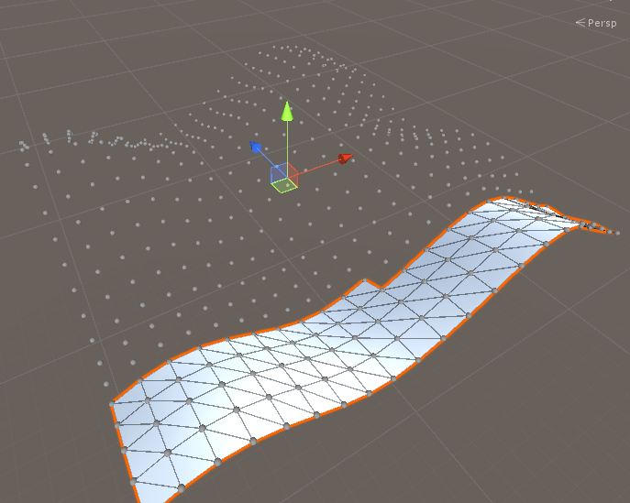

Figure 1 - Mesh Terrain Generation

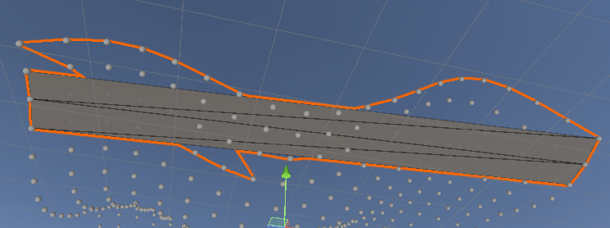

Figure 2 - Generation Mesh Problem

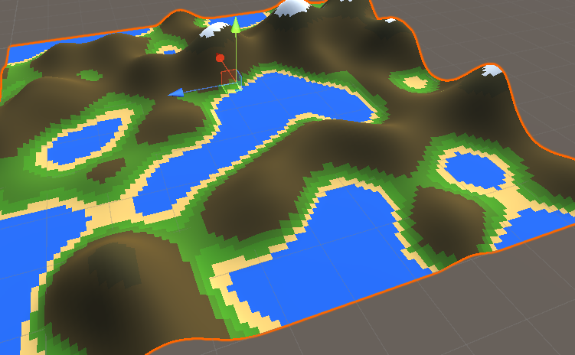

Figure 3 - Terrain Generation with low level of lacunarity

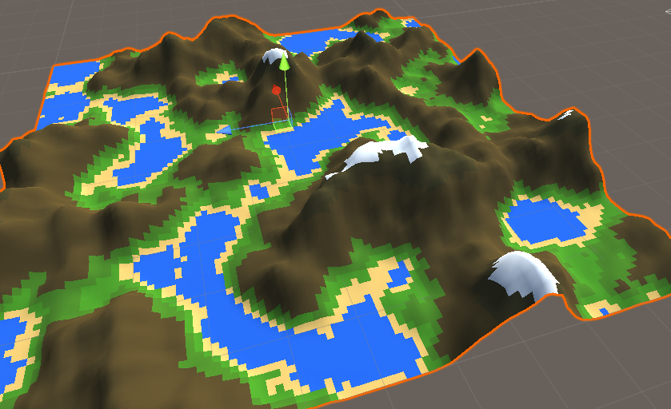

Figure 4 - Terrain Generation with high level of lacunarity



Figure 5 - Evaluate function in Animation Curve

#### WBS

1. Research (35%) (8 hours)
2. Create a Mesh Class (50%) (12 hours)
3. Display the terrain using the heightmap inside the mesh class (15%) (3 hours)

## 3.5 Sprint 5 – Graphic interface to change the terrain generation on the go and Level of detail implementation 09/03/2019 – 18/03/2019

### Abstract

The goal of this sprint is to create a graphic interface were the user can change the terrain settings and the level of detail of the terrain during the execution of the program. The level of detail of the terrain is going to be used in a later sprint to create an endless terrain.

### Research

Previous knowledge in the creation of user interface for unity is going to be used. For the implementation of the LOD (Level of Detail) all the information that I found was using the pre-build functionality in unity. I tried to figure out a way how I could implement this functionality by myself (Figure 5).

### Sprint Review

During the implementation of sprint, creating the user interface was a straight forward process without any major issues (Figure 1).

The problems start rising when implementing a way to reduce the level of detail of the terrain. One of the problems that took me some time to understand how to solve it, was the fact that each time I decreased the level of detail some quads on the mesh were not rendered properly (Figure 2). To resolve this issue duplicated my function named SetMeshData with an int parameter, this allowed to update my mesh data by passing the map size / level of detail (Figure 3). Now that the level of detail of the terrain was decreased, but some of the triangles were invisible I had to debug the program and going through the code, but I couldn’t find a way to fix it. I Tried to google it and research about Unity Level of Detail but the information that I found was not helpful at all, so I decided to draw my programming logic on the notebook (Figure 5), this not only helped me to figure out the solution but also opened my possibilities. I decided to make the terrain map ${255}^{2}$, but I needed to know what numbers I could use to divide 255 without giving me a float value, to solve this I found that the factors of 255 were 1,3,5,15,17,61,85,255 (Figure 6). When I found the factors of 255 Implementing the final solution was easy (Figure 7).

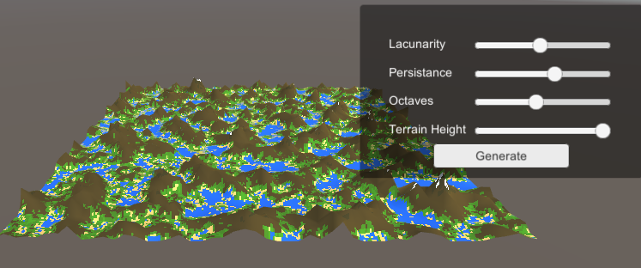

Figure 1 - User Interface

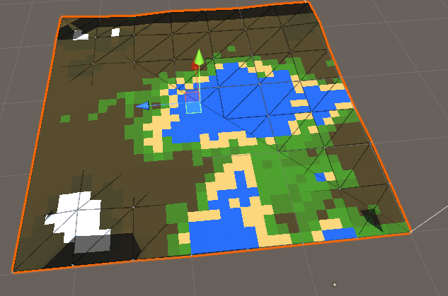

Figure 2 - Rendering Problem

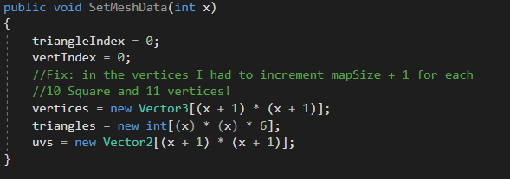

Figure 3 - Creation of the new function SetMeshData(int x)

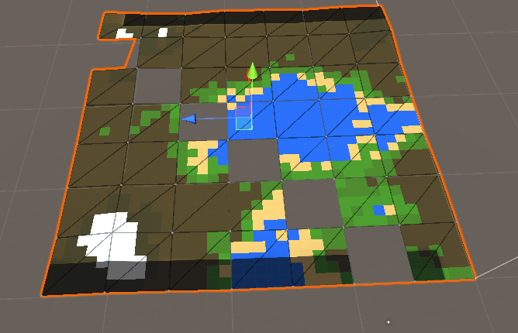

Figure 4 - Terrain Rendering, invisible triangles

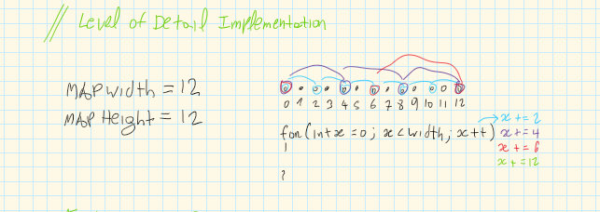

Figure 5 – LOD

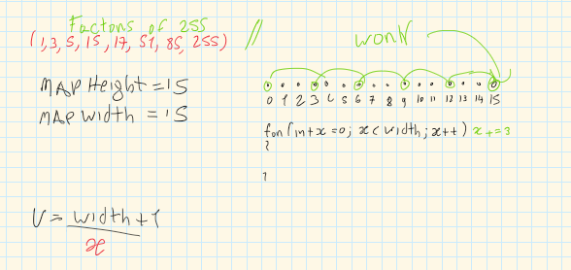

Figure 6 - Final Solution

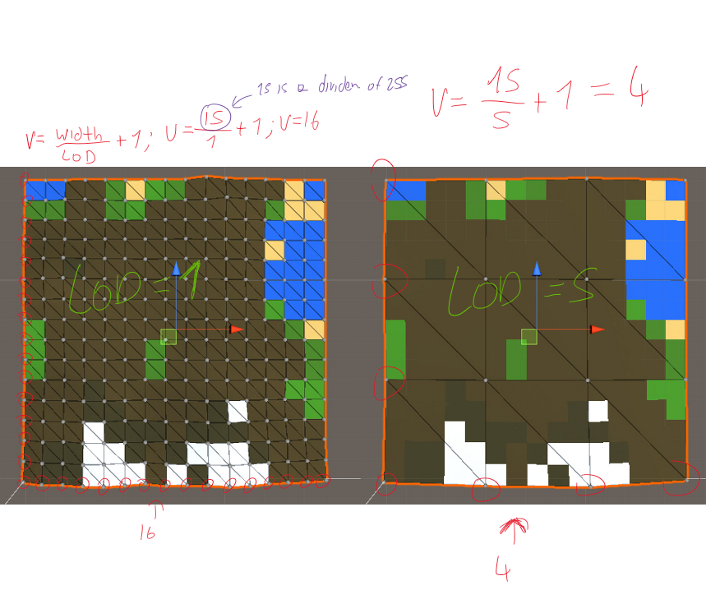

Figure 7 - Level of Detail Working

### WBS

1. Research (30%) (24 hours)
2. Implement graphical user interface (8%) (6 hours)
3. Implement the level of detail functionality (62%) (48 hours)

### GANTT



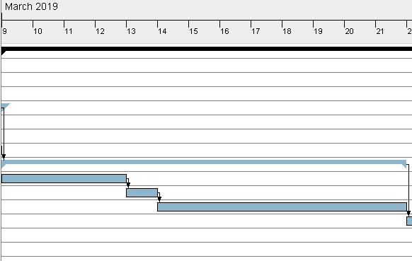

## 3.6 Sprint 6 – Studying fractals and fractal implementation for future using in hydraulic erosion 22/03/2019 – 05/04/2019

### Research

After researching for a few hours, I came across an application named Instant Terra, this is a 3D application made in C++ for Procedural Terrain Generation. I used this application and got an idea in what I should expect from the hydraulic erosion in my terrain (Figure 1, Figure 2 and Figure 3).

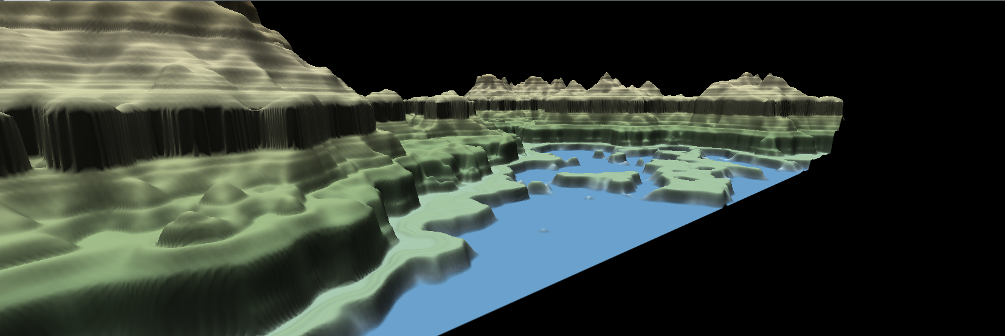

Figure 1 - Instant Terra, terrain without hydraulic erosion

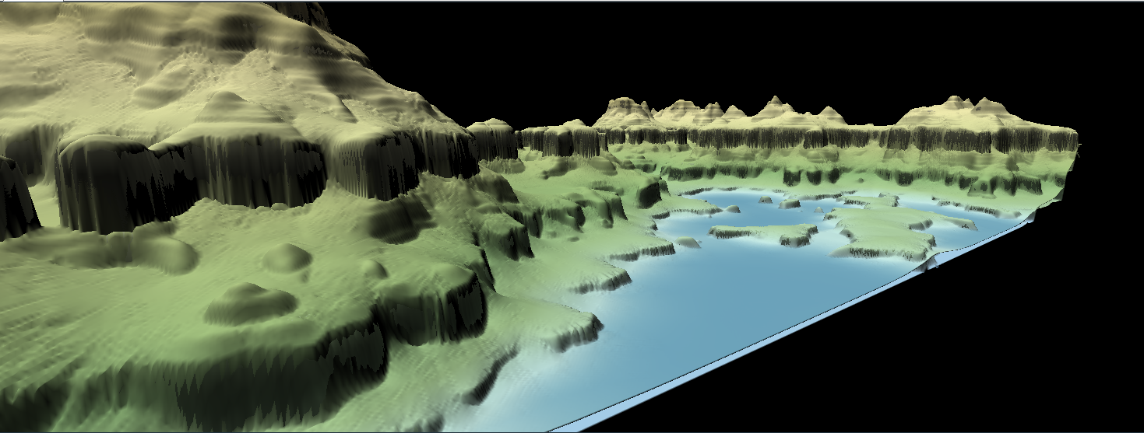

Figure 2 - Instant Terra, terrain with hydraulic erosion

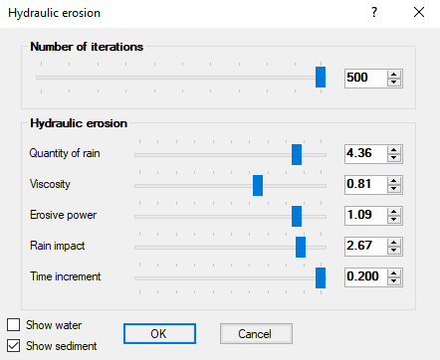

Figure 3 - Instant Terra, hydraulic erosion settings

The first step when reading the journal (Génevaux et al. 2013), I figure out that I needed to learn how to create fractals.

After a quick search, I found that for drawing basic lines I needed to learn how to use the LineRender in unity (Unity School 2016) [Figure 4].



Figure 4 - Fractals Step 1

#### Line Class

First, I started creating a Line Class, this class have a method for Drawing a line, each time is called it creates a game object and it stores it inside a list. The struggle here was to draw the line and being able to draw the next line saving the position from the line before and apply a specific rotation if needed. To be able to do this I created two vector 3, variables, a quaternion and a Boolean for checking if this is the first line (Figure 5).

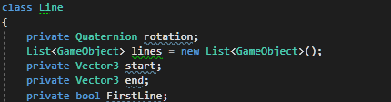

Figure 5 - Line Class Variables

I defined that the game object position is going to be equal to the start position and, in the end, when the line is created, the start position is going to be equals to the end position. When going through the list I had to find a way to check if the line was not drawn yet, for this I did an if statement to check if the game object had the line Renderer component, if not then draw the next line (Figure 6).

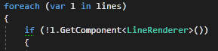

Figure 6 - Check if the line is already drawn

On the branch function the first line draws a line with the length defined in the parameter, the next code sets the rotation for the next line and after draws another line (Figure 4) (Figure 7).

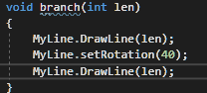

Figure 5 - Line Drawing

When I am trying to call this function recursively, I am getting this strange problem (Figure 8), it seems that I need to find the exact point were the line finishes and apply the translation from that point.



Figure 6 - Error when calling the function with recursion

The problem seems to be on the position for each line, to solve this problem I set the object position equals to the last object position multiplying by the last object rotation.

After many hours spent on the attempt to create a fractal, I ended up with two interesting fractal pattern using only lines in unity (Figure 9)(Figure 10). My end goal is to be able to create different patterns for example a tree, this technique is going to allow me to draw the water paths for the hydraulic erosion.



Figure 7 - Random Fractal by Flavio Fiori



Figure 8 - Random Pattern 2

#### Fractal Tree

Not happy with the result from the previous attempt to generate fractals, I took a different approach.

I decided to create an empty game object that is going to have a cube has a child and create a script for the empty game object.

##### Fractals Script

This script is responsible for the recursion of the game object, and to achieve this result, different from the previous time where I was using a line renderer, now I just instantiate a copy of the game object itself [Figure 9].

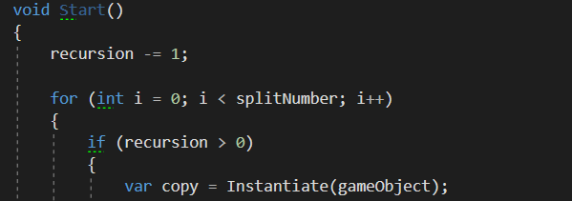

Figure 9 - Recursion for the game object

When the copy variable is created with the game object, the goal is to create another variable to store the script where I am going to use a method named Send Message, this method allows to call any method in a class that derives from MonoBehaviour (Unity 2018) [Figure 10].



Figure 10 - Using Send Message Method()

##### Expander Script

This script contains the method that is called from the SendMessage() method that is used on the Fractal Script [Figure 10].

This method is named Created and have a RecursionScript has a parameter, this script is responsible to store the value from “i” in the for loop. For example, let’s say that the splitNumber value is 2, then the “i” can be 0 or 1. When the “i” is 1 then the rotation is positive when the “i” is 0 the rotation is negative due to the fact that multiplying 0 by * 2 is 0 then subtracting 1 is -1. [Figure 11].

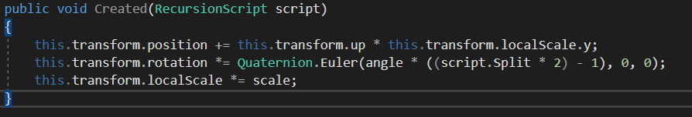

Figure 11 - Created Method

##### Recursion Script

This script is only responsible to hold the value from split and then use it to know the direction that is rotating.

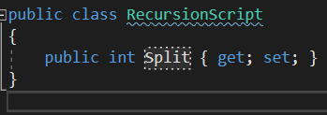

Figure 12 - Recursion Script

##### Conclusion

Now that the code was working has intended the result using the cubes started to look like a tree, I called this a fractal cube [Figure 13].

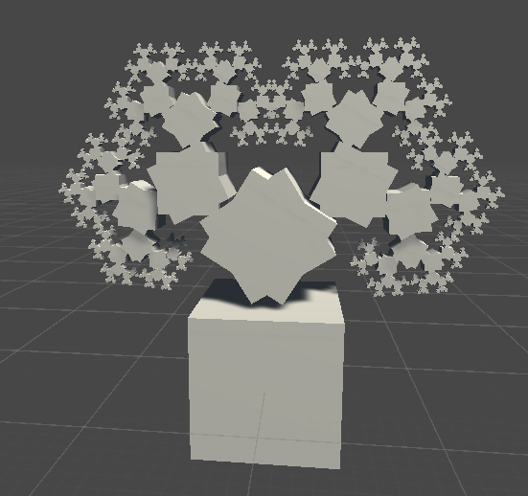

Figure 13 - Fractal Cube

I decided to rescale the cube to look alike a branch from a tree, using the cube scale has follow: x = 0.1, y = 1 and z = 0.1

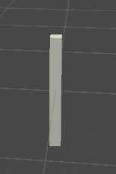

Figure 14 - Tree Branch

Now that I created the tree branch, I compiled the code once again, the result was far from what I expected [Figure 15].

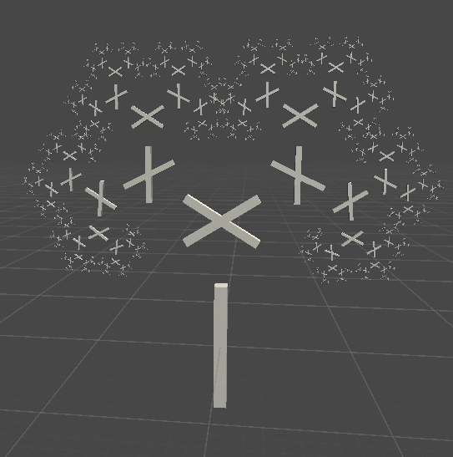

Figure 15 - Tree Generation Failed

After a while looking for a solution, I found that changing the position from the cube inside the parent was improving my results, I changed the Cube Position to Y = 1 [Figure 16].

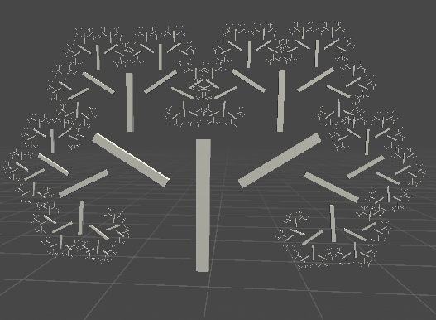

Figure 16 - Cube Y Position changed to 1

Not satisfied with the results, after playing for a while I found that the perfect Position for Y was 0.5, and the result was exactly what I was looking for, the fractal tree [Figure 17].

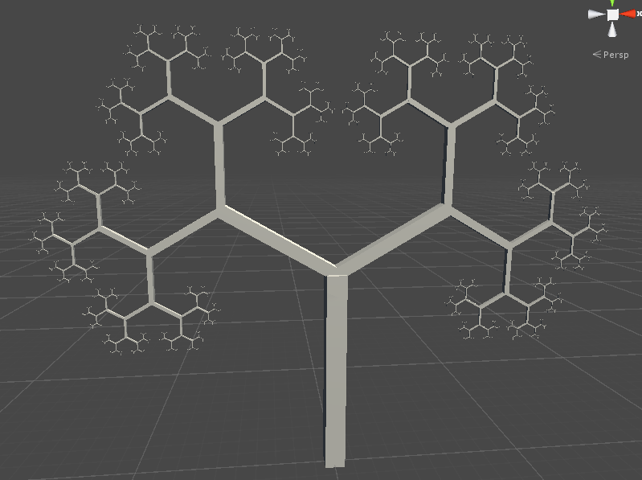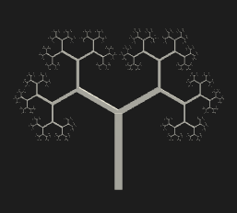

Figure 17 - Fractal tree

### Sprint Review

### WBS

1. Research (60%) (36 hours)
2. Fractal Generation (40%) (24 hours)

## 3.7 Sprint 7 – Hydraulic erosion 06/04/2019 – 01/05/2019

# References

ANDERSON, D.J., 2010. Kanban. Sequim, Wash: Blue Hole Press

CIRILLO, F., 2006. The Pomodoro Technique. [viewed 02/05/ 2018]. Available from: <http://baomee.info/pdf/technique/1.pdf>

CIRILLO, F., 2017. Do more and have fun with time management. [viewed 02/05/ 2018]. Available from: <https://francescocirillo.com/pages/pomodoro-technique/book/>

CUMMINGS, T., 2018. The Pomodoro Technique: Is It Right For You? [viewed 02/05/ 2018]. Available from: <https://www.lifehack.org/articles/productivity/the-pomodoro-technique-is-it-right-for-you.html>

FINLEY, K., 2014. WHY A SIMPLE TO-DO LIST TOOL IS WINNING OVER LEGIONS OF FANS [viewed 23/02/ 2019]. Available from: <https://www.wired.com/2014/08/why-a-simple-to-do-list-tool-is-winning-over-legions-of-fans/>

FOURNIER, A., D. FUSSELL and L. CARPENTER, 1982. Computer rendering of stochastic models. Communications of the ACM, Jun 1, 371-384

MARCUS HAMMARBERG and JOAKIM SUNDÉN, 2014. Kanban in Action. Manning Publications

OLSE, J., 2004. Realtime Procedural Terrain Generation. Department of Mathematics and Computer Science. University of Southern Denmark

OLSEN, J., 2004. Realtime Synthesis of Eroded Fractal Terrain for Use in Computer Games. Department of Mathematics and Computer Science

PETERSON, D., 2015. What is Kanban? [viewed 02/05/ 2018]. Available from: <http://kanbanblog.com/explained/>

PERLIN, K., 2002a. Improved Noise reference implementation [viewed 13/02/ 2019]. Available from: <https://mrl.nyu.edu/~perlin/noise/>

PERLIN, K., 2002b. Improving noise. ACM Transactions on Graphics (TOG), 21(3), 681-682

RIVEN, 2010. Calculate PerlinNoise faster with an optimization to grad(). In: August, Available from: <http://riven8192.blogspot.com/2010/08/calculate-perlinnoise-twice-as-fast.html>

ROHDE, S., 2013. Weathering and Erosion Basics [viewed 28/02/ 2019]. Available from: <https://www.youtube.com/watch?time_continue=0&v=CNUzTmPKxv8>

ROTHMAN, J., 2017. Why We All Use Timeboxes Available from: <https://www.agilealliance.org/why-we-all-use-timeboxes/>

SOFTWARE ADVICE, 2017. KanbanFlow Software [viewed 23/02/ 2019]. Available from: <https://www.softwareadvice.com/uk/project-management/kanbanflow-profile/>

ZUCKER, M., 2001. The Perlin noise math FAQ [viewed 10/02/ 2019]. Available from: <https://mzucker.github.io/html/perlin-noise-math-faq.html>

# Bibliography

ALEXANDRE PHILIPPE MANGRA, ADRIAN SABOU and DORIAN GORGAN, 2016. TSCH Algorithm - Terrain Synthesis from Crude Heightmaps. Romanian Journal of Human - Computer Interaction, 9(2), 119Top of Form

Bottom of Form

ANDERSON, D.J., 2010. Kanban. Sequim, Wash: Blue Hole Press

BECK, S., 2013. Minecraft in Unity 3D [Flashing Images] - One-Week Programming Challenge [viewed 10/01/ 2019]. Available from: <https://www.youtube.com/watch?v=qdwUkYrHosk&t=>

CIRILLO, F., 2006. The Pomodoro Technique. [viewed 02/05/ 2018]. Available from: <http://baomee.info/pdf/technique/1.pdf>

CIRILLO, F., 2017. Do more and have fun with time management. [viewed 02/05/ 2018]. Available from: <https://francescocirillo.com/pages/pomodoro-technique/book/>

CUMMINGS, T., 2018. The Pomodoro Technique: Is It Right For You? [viewed 02/05/ 2018]. Available from: <https://www.lifehack.org/articles/productivity/the-pomodoro-technique-is-it-right-for-you.html>

ESTEVEZ, C., 2019. What is HacknPlan? [viewed 23/02/ 2019]. Available from: <https://hacknplan.com/knowledge-base/what-is-hacknplan/>

FINLEY, K., 2014. WHY A SIMPLE TO-DO LIST TOOL IS WINNING OVER LEGIONS OF FANS [viewed 23/02/ 2019]. Available from: <https://www.wired.com/2014/08/why-a-simple-to-do-list-tool-is-winning-over-legions-of-fans/>

FLAFLA2, 2014. Understanding Perlin Noise [viewed 28/02/ 2019]. Available from: <http://flafla2.github.io/2014/08/09/perlinnoise.html>

FOURNIER, A., D. FUSSELL and L. CARPENTER, 1982. Computer rendering of stochastic models. Communications of the ACM, Jun 1, 371-384

GAMEDESIGNING, 2018. We Review The Hacknplan App [viewed 23/02/ 2019]. Available from: <https://www.gamedesigning.org/gaming/hacknplan/>

GÉNEVAUX, J. et al., 2013. Terrain generation using procedural models based on hydrology. ACM Transactions on Graphics (TOG), 32(4), 1-13

JAVIDX9, 2017. Programming Perlin-like Noise (C++) [viewed 01/03/ 2019]. Available from: <https://www.youtube.com/watch?v=6-0UaeJBumA>

NESO ACADEMY, 2018. Bitwise Operators in C (Part 2) [viewed 01/03/ 2019]. Available from: <https://www.youtube.com/watch?v=8aFik6lPPaA>

OLSE, J., 2004. Realtime Procedural Terrain Generation. Department of Mathematics And Computer Science, University of Southern Denmark,

OLSEN, J., 2004. Realtime Synthesis of Eroded Fractal Terrain for Use in Computer Games. Department of Mathematics And Computer Science,

PERLIN, K., Noise and Turbulence [viewed 28/02/ 2019]. Available from: <https://mrl.nyu.edu/~perlin/doc/oscar.html#noise>

PERLIN, K., 1985. An Image Synthesizer

PERLIN, K., 2001. Noise Hardware [viewed 27/02/2019]. Available from: <https://www.csee.umbc.edu/~olano/s2002c36/ch02.pdf>

PERLIN, K., 2002a. Improved Noise reference implementation [viewed 13/02/ 2019]. Available from: <https://mrl.nyu.edu/~perlin/noise/>

PERLIN, K., 2002b. Improving noise. ACM Transactions on Graphics (TOG), 21(3), 681-682

RIVEN, 2010. Calculate PerlinNoise faster with an optimization to grad(). In: August, Available from: <http://riven8192.blogspot.com/2010/08/calculate-perlinnoise-twice-as-fast.html>

ROHDE, S., 2013. Weathering and Erosion Basics [viewed 28/02/ 2019]. Available from: <https://www.youtube.com/watch?time_continue=0&v=CNUzTmPKxv8>

ROTHMAN, J., 2017. Why We All Use Timeboxes Available from: <https://www.agilealliance.org/why-we-all-use-timeboxes/>

SMELIK, R.M. et al., 2009. A Survey of Procedural Methods for Terrain Modelling.

SOFTWARE ADVICE, 2017. KanbanFlow Software [viewed 23/02/ 2019]. Available from: <https://www.softwareadvice.com/uk/project-management/kanbanflow-profile/>

THE CODING TRAIN, 2015. I.5: Perlin Noise - The Nature of Code [viewed 28/02/ 2019]. Available from: <https://www.youtube.com/watch?v=8ZEMLCnn8v0>

THE CODING TRAIN, 2016. 13.1: Introduction - Perlin Noise and p5.js Tutorial [viewed 28/02/ 2019]. Available from: <https://www.youtube.com/watch?v=Qf4dIN99e2w>

ZUCKER, M., 2001. The Perlin noise math FAQ [viewed 10/02/ 2019]. Available from: <https://mzucker.github.io/html/perlin-noise-math-faq.html>

# Appendix

## Appendix A) Reading List

ALEXANDRE PHILIPPE MANGRA, ADRIAN SABOU and DORIAN GORGAN, 2016. TSCH Algorithm - Terrain Synthesis from Crude Heightmaps. Romanian Journal of Human - Computer Interaction, 9(2), 119

Top of Form

Bottom of Form

FOURNIER, A., D. FUSSELL and L. CARPENTER, 1982. Computer rendering of stochastic models. Communications of the ACM, Jun 1, 371-384

GÉNEVAUX, J. et al., 2013. Terrain generation using procedural models based on hydrology. ACM Transactions on Graphics (TOG), 32(4), 1-13

OLSE, J., 2004. Realtime Procedural Terrain Generation. Department of Mathematics and Computer Science, University of Southern Denmark,

OLSEN, J., 2004. Realtime Synthesis of Eroded Fractal Terrain for Use in Computer Games. Department of Mathematics and Computer Science,

PERLIN, K., 1985. An Image Synthesizer

PERLIN, K., 2001. Noise Hardware [viewed 27/02/2019]. Available from: <https://www.csee.umbc.edu/~olano/s2002c36/ch02.pdf>

PERLIN, K., 2002. Improving noise. ACM Transactions on Graphics (TOG), 21(3), 681-682

SMELIK, R.M. et al., 2009. A Survey of Procedural Methods for Terrain Modelling.

## Appendix B) Literature review

### B.1) Terrain Synthesis Techniques Research

**THE CODING TRAIN, 2015. *I.5: Perlin Noise - The Nature of Code*[viewed 28/02/ 2019]. Available from:**[**https://www.youtube.com/watch?v=8ZEMLCnn8v0**](https://www.youtube.com/watch?v=8ZEMLCnn8v0)

**THE CODING TRAIN, 2016. *13.1: Introduction - Perlin Noise and p5.jsTutorial*[viewed 28/02/ 2019]. Available from:**[**https://www.youtube.com/watch?v=Qf4dIN99e2w**](https://www.youtube.com/watch?v=Qf4dIN99e2w)

These two videos introduced to me the Perlin Noise algorithm and how it works. They discuss that Perlin Noise is a pseudo-random noise, meaning that the values are not random at all, but the increment in a slow way, between the value 0 and 1.

**BECK, S., 2013. *Minecraft in Unity 3D [Flashing Images] - One-Week Programming Challenge*[viewed 28/02/ 2019]. Available from:**[**https://www.youtube.com/watch?v=qdwUkYrHosk&t=**](https://www.youtube.com/watch?v=qdwUkYrHosk&t=)

This link shows a finish product in unity, where the user develops a voxel world like Minecraft, using procedural terrain generation.

### B.2) Perlin Noise Research

**PERLIN, K., 2002. Improving noise. *ACM Transactions on Graphics (TOG),*21(3), 681-682**

This was the first Perlin Noise academic journal that I came across, practically this journal refers that the original algorithm of noise had two deficiencies.

Un-optimal gradient computation, in other words the gradient function was replaced by 12 defined vectors. The other deficiency was found on the fade function $3^{t2}-{2t}^{3}$ that was after replaced by $6^{t}-{15}^{t4}+{10}^{t3}$.

**FLAFLA2, 2014. *Understanding Perlin Noise*[viewed 28/02/ 2019]. Available from:**[**http://flafla2.github.io/2014/08/09/perlinnoise.html**](http://flafla2.github.io/2014/08/09/perlinnoise.html)

“Understanding Perlin Noise”, was in this web page that I learned all about the algorithm and how to recreate a working version of the Perlin Noise. This is just a copy of the original Perlin Noise but updated to the improved version of the algorithm.

**ZUCKER, M., 2001. *The Perlin noise math FAQ*[viewed 10/02/ 2019]. Available from:**[**https://mzucker.github.io/html/perlin-noise-math-faq.html**](https://mzucker.github.io/html/perlin-noise-math-faq.html)

This source is a combination from the Ken Perlin’s Making Noise web site, and the Higo Elia’s page, but unfortunately this web pages were taken down.

**PERLIN, K., *Noise and Turbulence*[viewed 28/02/ 2019]. Available from:**[**https://mrl.nyu.edu/~perlin/doc/oscar.html#noise**](https://mrl.nyu.edu/~perlin/doc/oscar.html#noise)

In this link Ken Perlin shows how to implement Perlin Noise function and how to do it using different dimensions functions.

**PERLIN, K., 1985. An Image Synthesizer**

Perlin describes five ideas for visual texture synthesis in this journal. The author introduces the concept of Pixel Stream Editor. Explaining how to develop efficient naturalistic looking textures. The author talks about how he used this system to create a believable representation of fire, water, clouds, waves, marble and oil films.

**RIVEN, 2010. Calculate Perlin Noise faster with an optimization to grad(). In: August, Available from:**[**http://riven8192.blogspot.com/2010/08/calculate-perlinnoise-twice-as-fast.html**](http://riven8192.blogspot.com/2010/08/calculate-perlinnoise-twice-as-fast.html)

The author discovered an efficient way to simplify the Perlin Noise algorithm changing the gradient function and making it twice as fast, returning the gradient directions in a simplified way instead of doing the complicated bit manipulation that Ken Perlin does on the original algorithm.

**NESO ACADEMY, 2018. *Bitwise Operators in C (Part 2)*[viewed 01/03/ 2019]. Available from:**[**https://www.youtube.com/watch?v=8aFik6lPPaA**](https://www.youtube.com/watch?v=8aFik6lPPaA)

This author thought me how the bitwise operators worked. This helped me understand how the bit manipulation of the gradient function of Ken Perlin worked.

**JAVIDX9, 2017. *Programming Perlin-like Noise (C++)*[viewed 01/03/ 2019]. Available from:**[**https://www.youtube.com/watch?v=6-0UaeJBumA**](https://www.youtube.com/watch?v=6-0UaeJBumA)

This author gives an overview and explains more in detail how to implement the algorithm in a different language like C++.

### B.3) Diamond-Square Research

**OLSE, J., 2004. Realtime Procedural Terrain Generation. Department of Mathematics and Computer Science, University of Southern Denmark**

In this journal the author implements the Diamond-Square algorithm, explaining how it works.

**OLSEN, J., 2004. Realtime Synthesis of Eroded Fractal Terrain for Use in Computer Games. *Department of Mathematics and Computer Science***

In this journal is where the idea of the diamond-square algorithm was introduced.

“First, we compute the boundary of the patch, using the one-dimensional version of the algorithm to the level desired. We then fill the square for each level, computing the centres, then the sides, using at each step the four neighbours (diagonally for the centres, horizontally and vertically for the sides). At each step the new point is computed as a Gaussian pseudo-random variable, whose expected value is the mean of the four neighbours at this level, and whose standard deviation is $c^{-lh}$, with $l$ the level, H the self-similarity parameter, and c a constant to be adjusted to fit the application” (Olse 2004)

## Appendix C) Images

### C.1) Prototype using the 2D Perlin noise function that I created

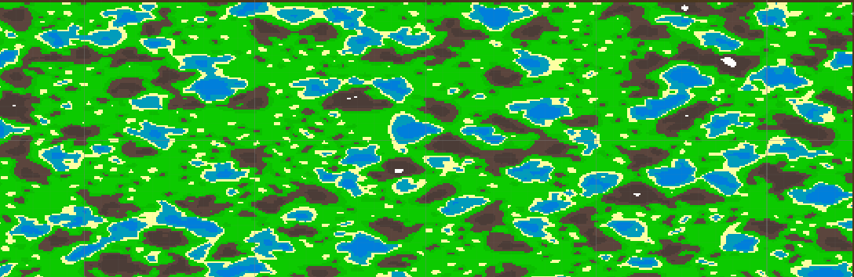

### C.2) Prototype using the Unity Perlin Noise Function

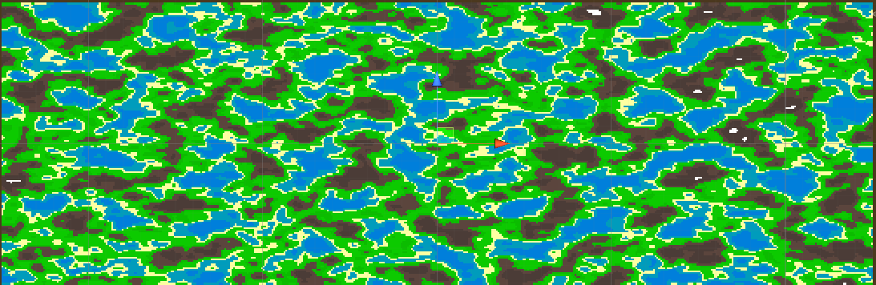

### C.3) Perlin Noise from my function

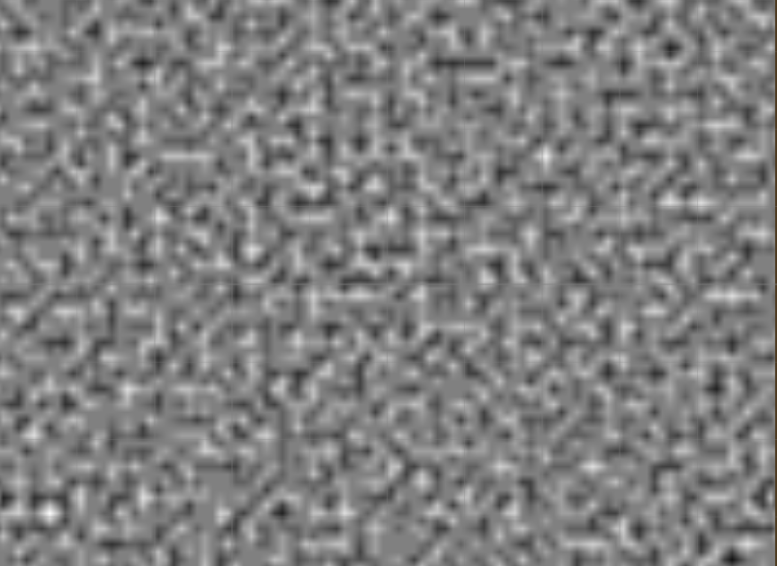

### C.4) Perlin Noise from unity

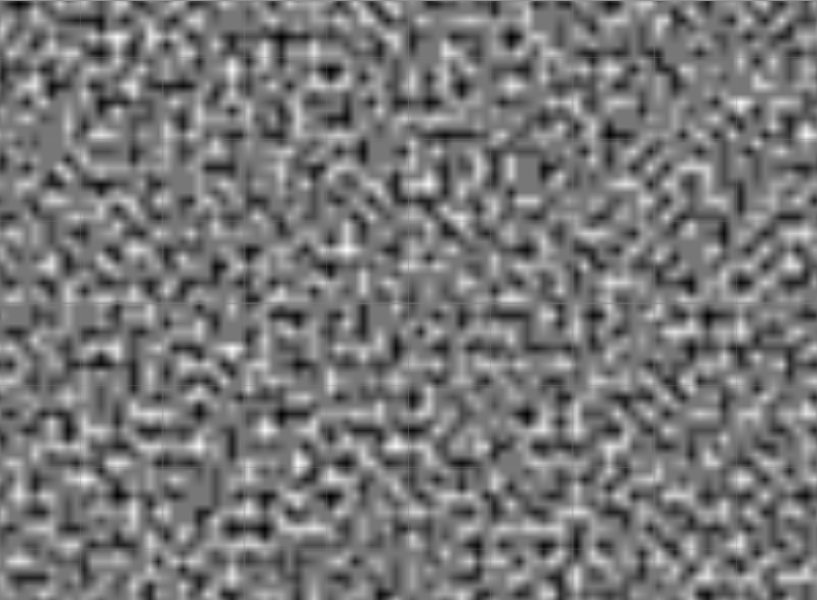

### C.5) Ken Perlin’s original gradient function

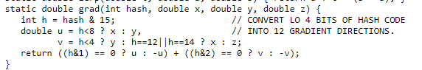

### C.6) Riven Calculate Perlin Noise twice as fast

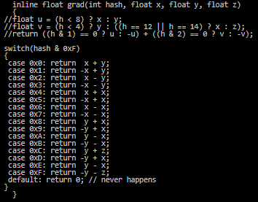

### C.7) Noise Displaced super quadric with old interpolants

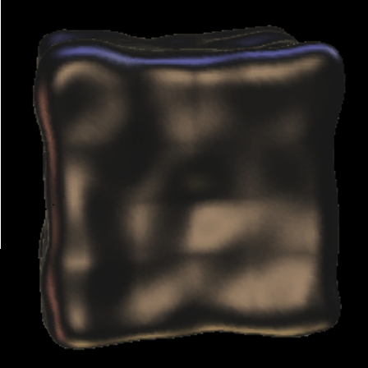

### C.8) Noise Displaced super quadric with new interpolants

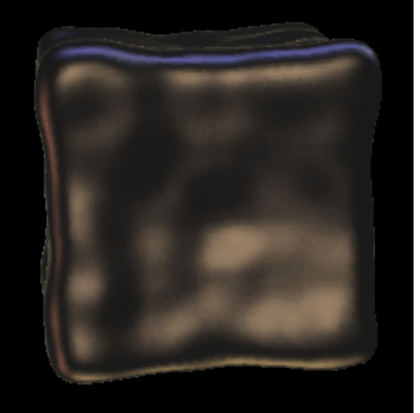

### C.9) Risk and Analysis



### C.10) Gantt Chart

